**Project Documentation: Encoding and Decoding Utility**

**Overview:**   
The Encoding and Decoding Utility is a small console application that allows users to convert strings of up to four characters into their encoded integer representations and then decode those integers back into the original strings. The application uses a combination of hexadecimal and binary conversions to achieve the encoding and decoding process. It provides an interactive user interface for input and displays the results on the console.

**How to Use the Utility:**

**Step 1: Run the Application**

* Open the console or terminal on your system.
* Compile and run the Program.cs file or the executable if available.

**Step 2: Encode**

* Upon running the application, you will be prompted to enter up to four characters.
* Type the desired characters and press Enter.

**Step 3: Decoding**

* The application will then display the encoded result in the format [encoded_values], where the encoded_values are integers separated by commas.
* The utility will also display the corresponding decoded string right after the encoded output.

**Important Notes:**

* The application handles strings of arbitrary length, but it processes them in groups of four characters at a time.
* If you enter a string with less than four characters, the utility will automatically pad it with zeros.
* The utility performs Two's Complement encoding, and the encoding process includes hexadecimal and binary conversions.

**Usage Examples:**

**Example 1:**

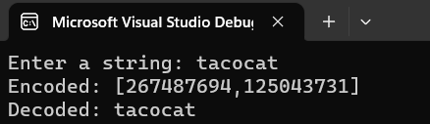

**Example 2:**

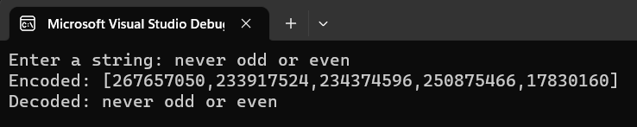  
  
  
**Conclusion:**

The Encoding and Decoding Utility provides a simple and interactive way to convert strings into their encoded integer representations and then decode them back into their original form. The project demonstrates the use of hexadecimal and binary conversions for encoding and Two's Complement representation. It can be useful for scenarios where such encoding and decoding requirements arise, and it offers a glimpse into production-quality code with appropriate commenting and organization.